

American International University-Bangladesh (AIUB)  
**Department of Computer Science  
Faculty of Science & Technology (FST)**

**Crime Management & Reporting System**

A Software Requirement Engineering Project Submitted

By

|  |  |  |  |  |
| --- | --- | --- | --- | --- |
| **Semester: Spring_22_23** | | **Section:** | **Group Number:** | |
| SN | Student Name | Student ID | Contribution (CO1+CO2) | Individual Marks |
| 14 | Romona Magdalene Sarkar | 20-42186-1 |  |  |
| 15 | MD. Shahzad Hussain Rayied | 20-42190-1 |  |  |
| 20 | Shahriar Hossain Rafi | 20-42528-1 |  |  |
| 21 | Md. Shakibur Rahman | 20-42723-1 |  |  |
| 38 | Lima Akter | 20-43806-2 |  |  |

The project will be Evaluated for the following Course Outcomes

|  |  |  |
| --- | --- | --- |
| Evaluation Criteria | Total Marks (50) | |
|  | |
| Revision History, Test Plan Identifier, Reference Materials, Problem Background, Solutions | [10 Marks] |  |
| Requirements Specification (System feature, Quality Attributes, System Interface, Project Requirements) | [10 Marks] |  |
| Item Not to be tested, Testing approach (Testing levels, tools, meetings), Test cases | [10 Marks] |  |
| Item pass/fail criteria, Test deliverables, Staffing and Training, Responsibilities, Scheduling, Risk | [10 Marks] |  |
| Approval, Format, Submission, and Defense | [10 Marks] |  |

Software Test Plan

for

Crime management & Reporting System

Version 1.3

Prepared by

AIUB

25th March 2023

Table of Contents

Revision History 3

1. TEST PLAN IDENTIFIER: AT-TP01.3 4

2. REFERENCES 4

3. INTRODUCTION 4

3.1 Background to the Problem 4

3.2 Solution to the Problem 4

4. REQUEIREMNT SPECIFICATION 4

4.1 System Features 4

4.2 System Quality Attributes 5

4.3 System Interface 5

4.4 Project Requirements 5

5. FEATURES NOT TO BE TESTED 5

6. TESTING APPROACH 5

6.1 Testing Levels 5

6.2 Test Tools 6

6.3 Meetings 6

7. TEST CASES/TEST ITEMS 7

8. ITEM PASS/FAIL CRITERIA 7

9. TEST DELIVERABLES 7

10. STAFFING AND TRAINING NEEDS 8

11. RESPONSIBILITIES 8

12. TESTING SCHEDULE 8

13. PLANNING RISKS AND CONTINGENCIES 9

14. APROVALS 9

# Revision History

|  |  |  |  |
| --- | --- | --- | --- |
| Revision | Date | Updated by | Update Comments |
| 0.1 | 25.3.2023 | Romona Sarkar |  |
| 0.2 | 30.3.2023 | Md. Shakibur Rahman |  |
| 0.3 | 10.4.2023 | Shahriar Hossain Rafi |  |
| 0.4 | 20.4.2023 | MD. Shahzad Hussain Rayied |  |
|  |  |  |  |
|  |  |  |  |
|  |  |  |  |
|  |  |  |  |
|  |  |  |  |

# TEST PLAN IDENTIFIER: CRM-1

# REFERENCES

1. Website development for a crime management system, S. Mishra (2022). Available at: https://www.researchgate.net/publication/358079049_website_development_of_crime_management_system?fbclid=IwAR1dbEiWMTuDfMmjcVTl6g2VdFFyDniSbqaXh_n8uDUp-RnyYZFZCPw (Mishra, 2022)
2. Venu, D. (2014). 52579903-Crime-Management-Reporting-System. *Tudelft*. https://www.academia.edu/7356494/52579903_Crime_Management_Reporting_System

# INTRODUCTION

## 3.1 Background to the Problem

Now a day’s crimes are increasing in a very high rate. From money laundering to security issues of an organization are being threatened. Internet crimes are very common in Bangladesh where the criminal doesn’t get known and the same crime rises high.

Bangladesh is a densely populated country where challenges come to the authorities responsible for maintaining law and order. In Bangladesh, violent crimes like murder and assault also happen, though less frequently than theft and robbery. Due to an increase in internet and digital gadget use, drug trafficking and cybercrime are both on the rise in Bangladesh. Online fraud, identity theft, and hacking are some of the most common types of cybercrime in the country.

Due to this problem we have prepared a project Crime management & Reporting System in Bangladesh where we can have some benefits / advantages to report crime efficiently and effectively.

## --1) crimes reports gula pore thakche dacha jacche j kono steps niwa hocche na fole kono action o niwa hocche na.

--Internet e crime prochur bere geche tai dhruto ekta action na nile dakha jay j crime ta thekano jayna eigulai background prbl amder desher tai ei website ta banana.

## 3.2 Solution to the Problem

The Development of a software program that can aid law enforcement organizations in better managing and tracking crimes would be the answer to the problem of "Crime Management & Reporting System". Citizens would be able to report crimes online via the system, including pertinent details such the incident's location and time as well as the sort of crime that was committed.

Additionally, the system ought to have a dashboard that law enforcement officials can use to view and control reported crimes. Officers should be able to prioritize their responses depending on the seriousness and urgency of each reported crime with the use of the dashboard, which should present real-time information on the status of each reported crime.

Additionally, the system ought to be able to produce reports and analytics on crime trends, giving law enforcement information.

1) dhutotar sathe crime er place shoho report kora

2) Urgent file/document upload kore report kora jabe

3) dashboard e crime post and wanted list thakbe oigula o news hisebe dacha jabe

4) victim /reporter can see real time status of their files

5) also they can complain about an incident.

# REQUEIREMNT SPECIFICATION

## 4.1. System Features

**1. System Login**  
Functional Requirements

* 1. The software shall allow users to login with their given username and password
  2. If the username and/or password has been inserted wrong for more than three times, the random verification code will be generated by the system to retry login.
  3. If the number of login attempt exceed its limit (5 times), the system shall block the user account login for one hour *[optional function]*

Priority Level: High  
Precondition: user have valid user id and password

1. **User Registration**

Functional Requirements

* 1. The software shall allow users to registration with their Gmail account, first name, last name, Nid, date of birth, phone number and password.
  2. User name, Phone Number and Email will be checked for registration. There will be no duplicate Email, Phone number and username.

Priority Level: High

1. **User Post Complain**

Functional Requirements

* 1. Users can post their complain in the system
  2. Complain will be verified and approved by the admin
  3. Users/Victim can post the complaint with the victim’s name or anonymously.

Priority Level: High  
Precondition: user have valid user id

1. **Report a case file**

Functional Requirements

* 1. Users can report file for a crime (critical cases) like murder, abuse, ford cases etc.
  2. Users will get their file/report viewed within 30mins by the admin and police department.

Priority Level: High  
Precondition: user have valid user id

1. **User View feedback**

Functional Requirements

* 1. Users can see the feedback from the police department
  2. Users can also see the feedback from admin

Priority Level: Moderate   
Precondition: User have requested a complain/report

1. **User View status**

Functional Requirements

* 1. Users can view the status of their reported file
  2. Users can see if it is viewed or not

Priority Level: Moderate   
Precondition: User have requested a complain/report

1. **Users can see the safety posts**

Functional Requirements

* 1. User can see the safety posts and comment on them.
  2. Users can share them with others.

Priority Level: Moderate   
Precondition: User have to be logged in

1. **All can see the news board**

Functional Requirements

* 1. News board contains new updated news about criminals and has wanted criminals posted in it. Users can see the posts.
  2. Users can share the post.

Priority Level: High  
Precondition: User have to be logged in

1. **Update & Delete info:**

Functional Requirements

* 1. The software shall allow admin to update any information in the system.
  2. The software will also allow admin to delete any information in the system
  3. Once a data has been updated it will need to wait for 7 days to again update it.

Priority Level: Moderate  
Precondition: Admin must take permission from user to update information.

1. **Approve post from user**:

Functional Requirements

* 1. The software will allow Admin will approve any post from users.
  2. If Admin rejects unnecessary posts from users, they need to wait for a day to post again.

Priority Level: Moderate  
Precondition:

1. **Assign investigation team:**

Functional Requirements

* 1. Admin can assign team of police officers for investigation for any crime case.
  2. Once a police officer has been assigned to a case, he/she cannot be assigned to another case at the same time.

Priority Level: High  
Precondition: Admin must assign police officers to particular case by their experience.

1. **Search Crime details:**

Functional Requirements

* 1. Police can search for any crime details.
  2. Police can search any crime details by using the case id.

Priority Level: High  
Precondition: Crime details must be stored in the system with a unique id.

1. **Update wanted list**:

Functional Requirements

* 1. Police can update wanted list.

Priority Level: High  
Precondition: Police must have has his own user id & Password.

1. **Write FIR:**

Functional Requirements

* 1. Police can write down FIR for a crime.
  2. Police must submit the FIR to the admin to store in the database System.

Priority Level: High  
Precondition: police must investigate properly to write the FIR.

1. **Crime status**:

Functional Requirements

* 1. Police can update crime status from their investigation
  2. Users should see the crime status all the time.

Priority Level: High  
Precondition: Crime status should be updated within 7 days.

1. **Close the case:**

Functional Requirements

* 1. Police can close the case.
  2. Police can take permission from the user if they want to drop the evidence.

Priority Level: High  
Precondition: Police must give final investigation report about the case to close the case.

## System Quality Attributes

**1. Usability:** The software should be simple to use. Because of the system's straightforward navigation and user-friendly features, new or occasional users can quickly become familiar with it. Users shall be able to complete common tasks within and average **one minutes.**

**2. Reliability and correctness:** Our program guarantees accuracy and provides the user with the exact outcome they are looking for. Already tested, no erroneous result was produced.

**3.Modularity**: We must construct each system module-by-module. Any module's bugs are simple to find, and then all that is left to do is fix that specific module. Additionally, because our system has been created module-by-module, we may also add new functionality to it.

**4.Maintainability:** It refers to how quickly the maintenance crew can do their duty. It is the system framework's capacity. Maintainability enables the establishment of the framework following a failure.

**5**. **Efficiency:** important aspect of system quality. measured in terms of the amount of time needed for whatever task the system is given to finish. The program will be highly effective on a wide scale.

**6. FLEXIBILITY:** Any module can be added to our system without any difficulty or hesitation. We have always kept the module architecture fairly straightforward so that we can simply add modules.

## System Interface

* To Design UI/UX of our Proposed Software Interface we will use the tool Figma.

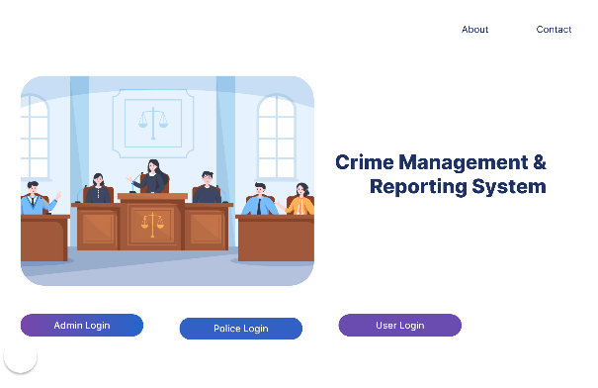

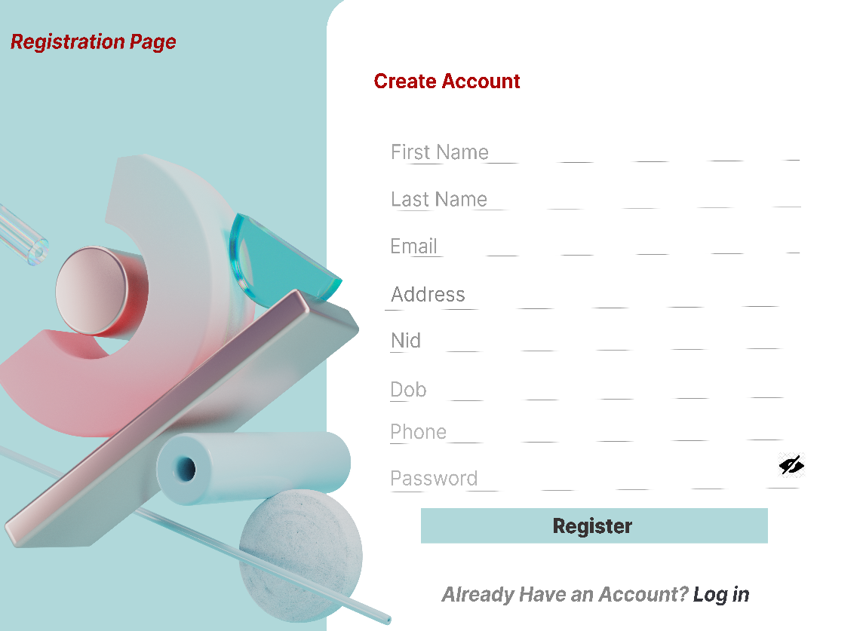

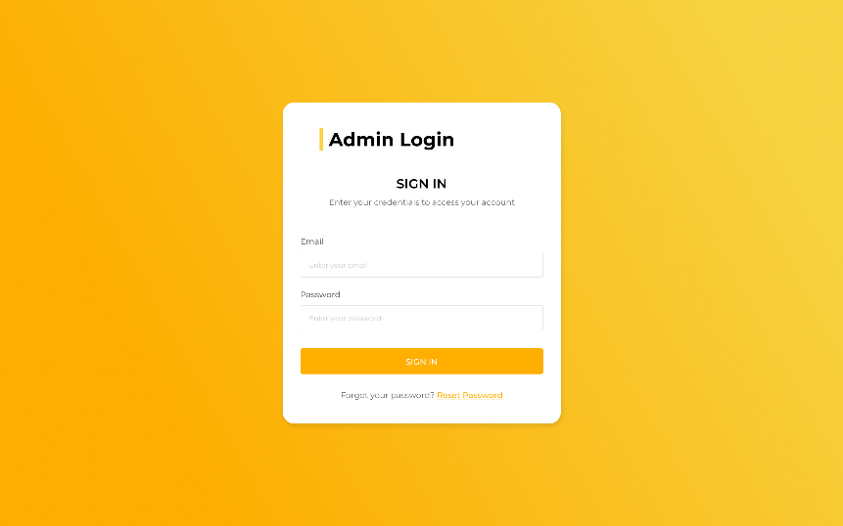

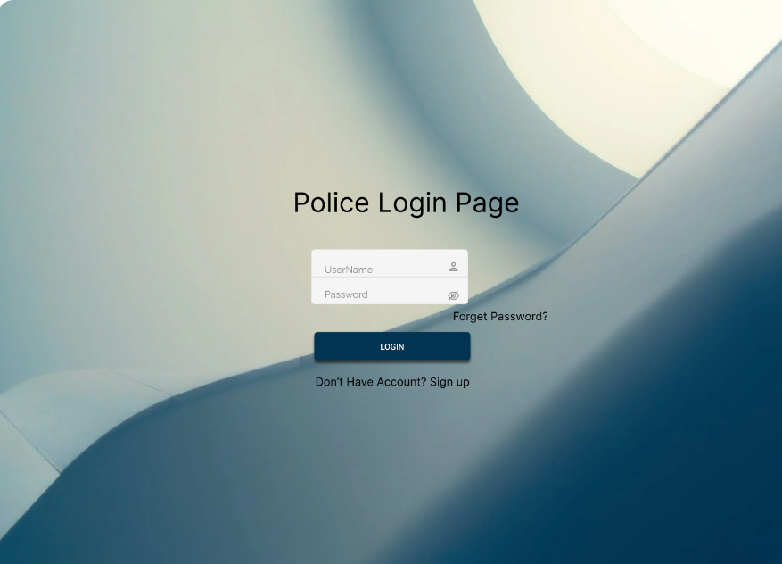

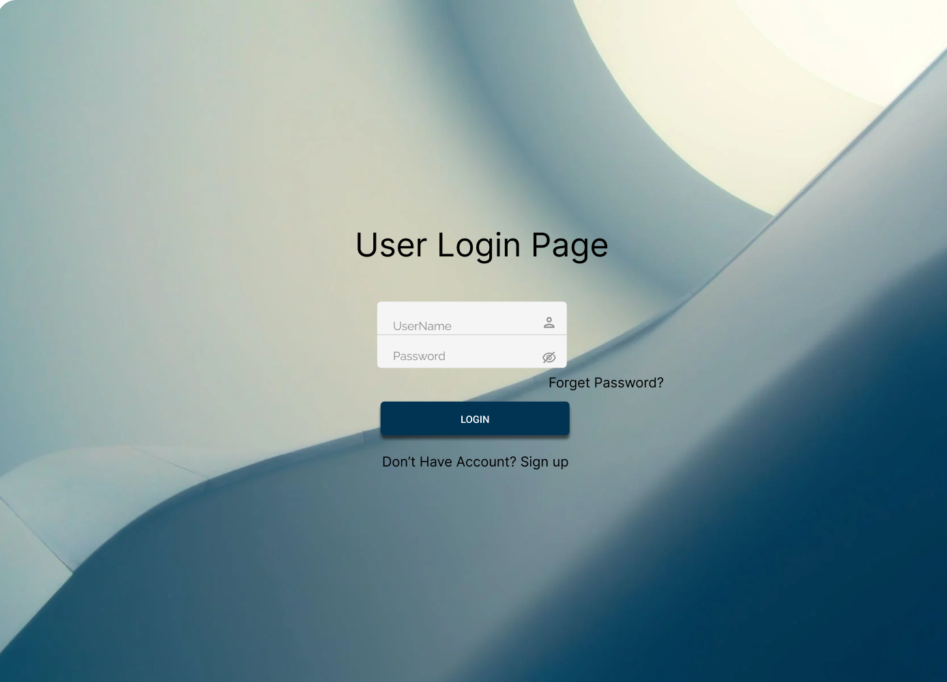

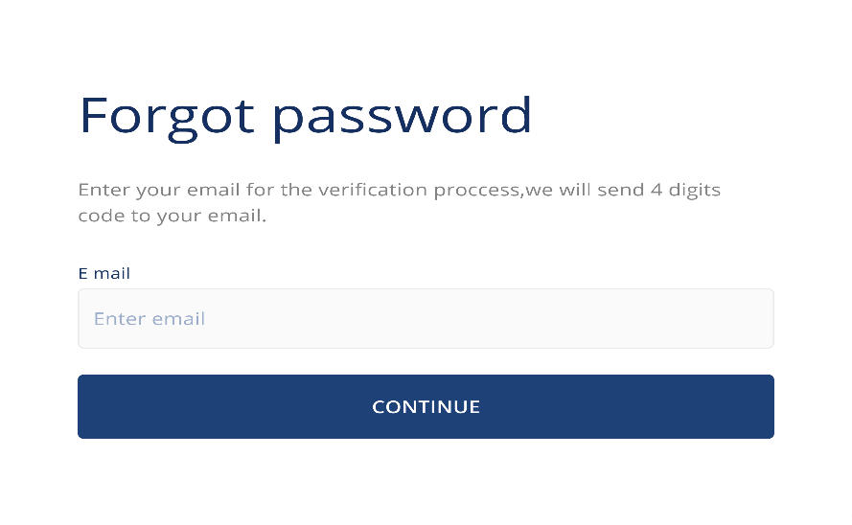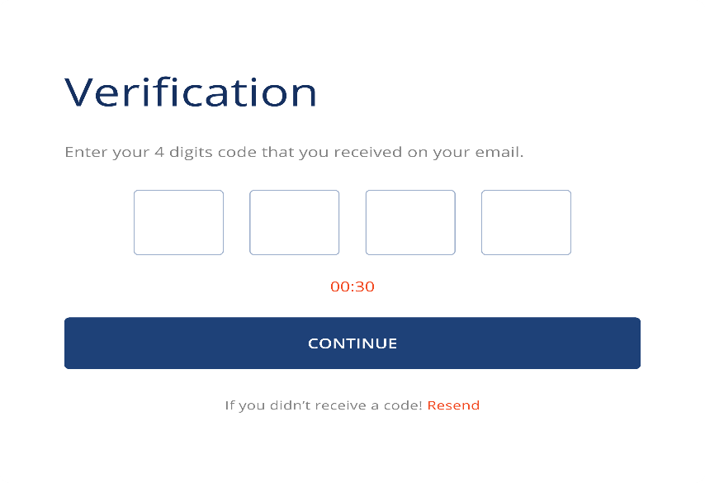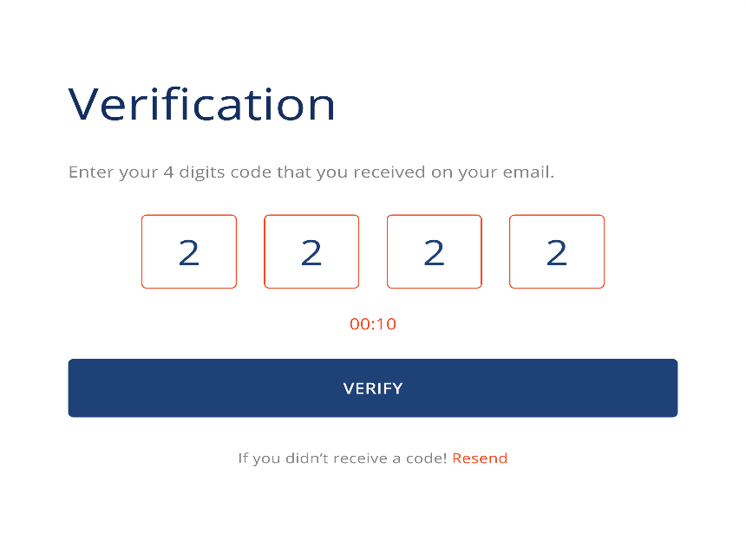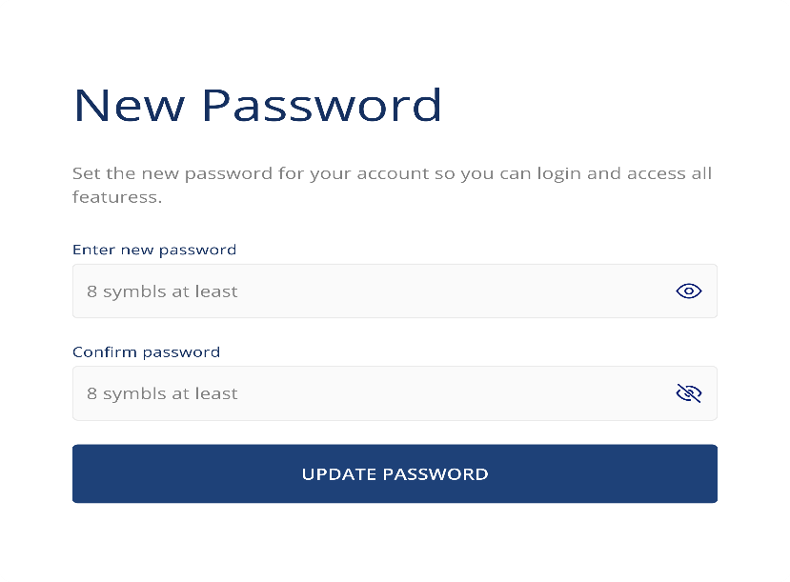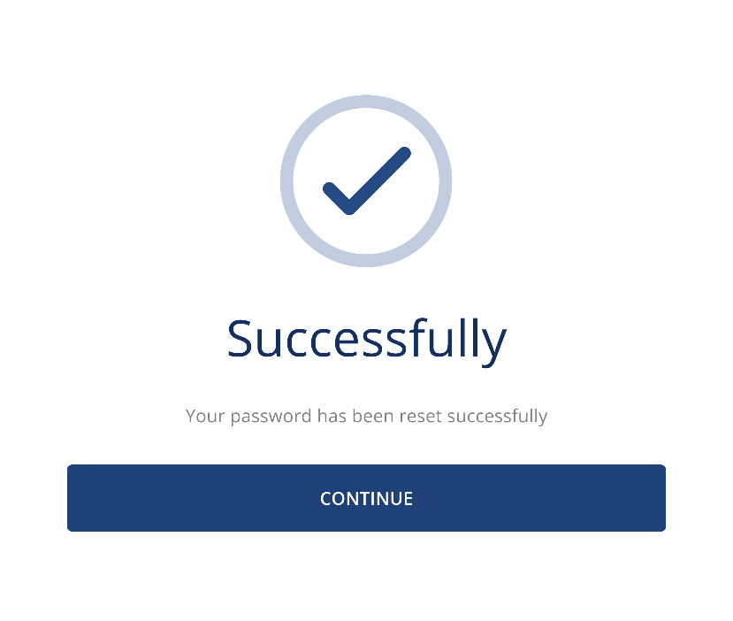

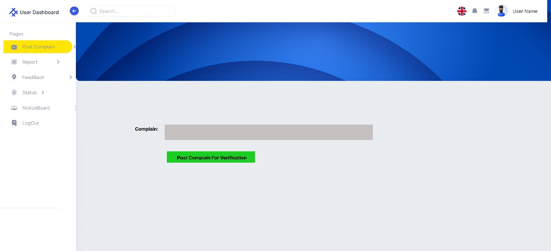

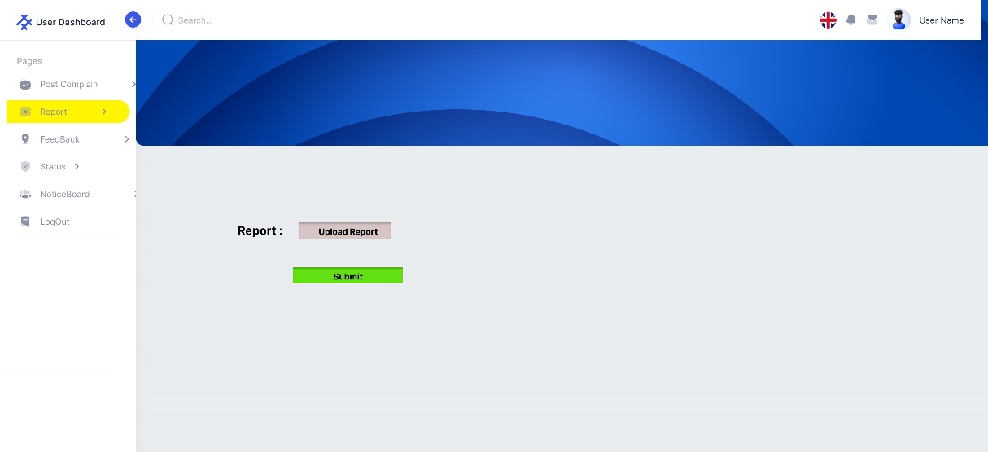

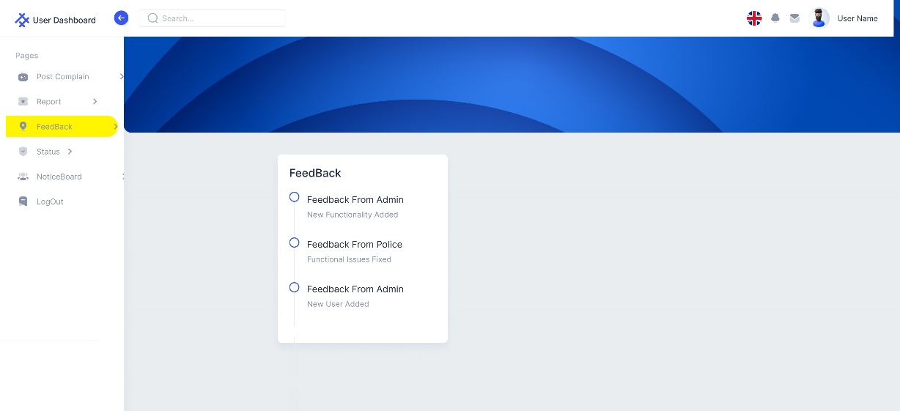

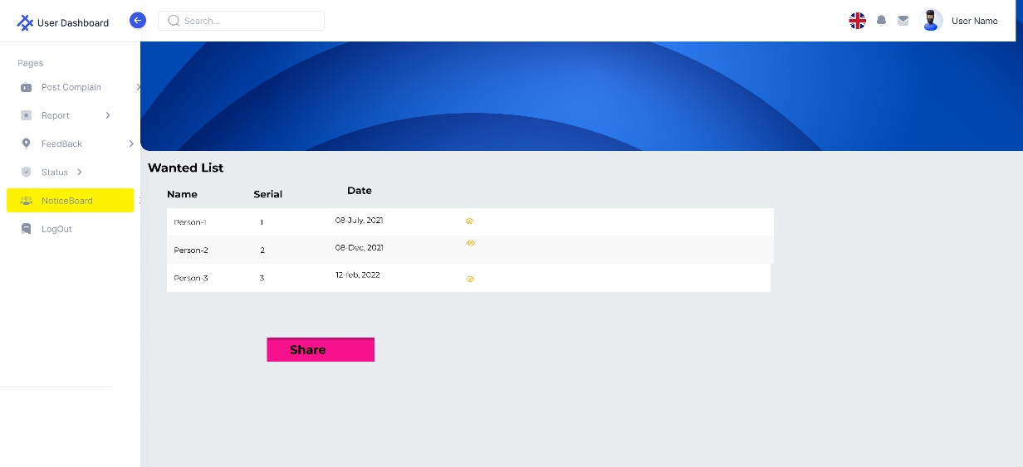

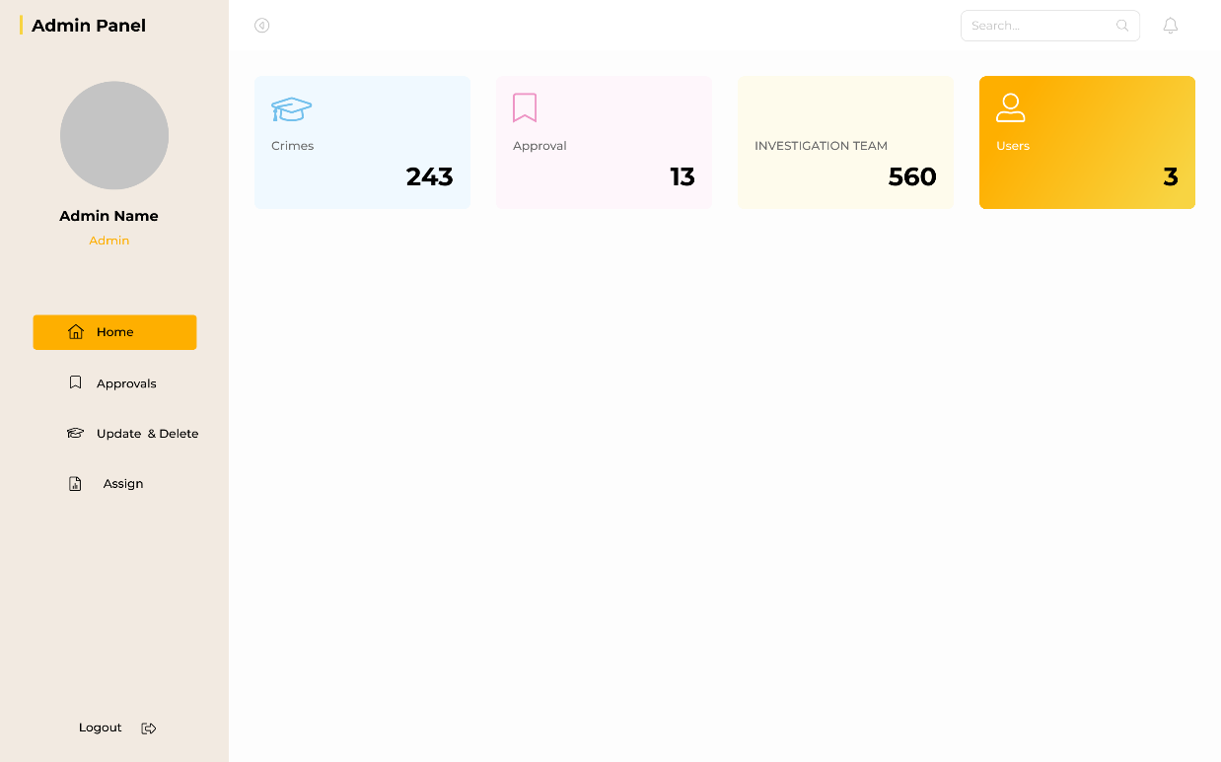

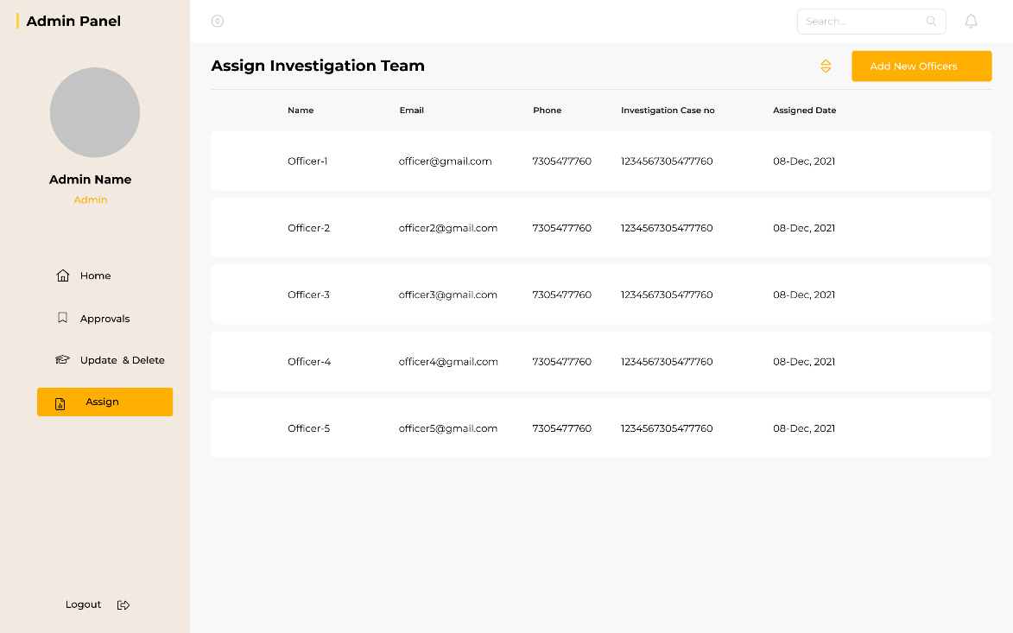

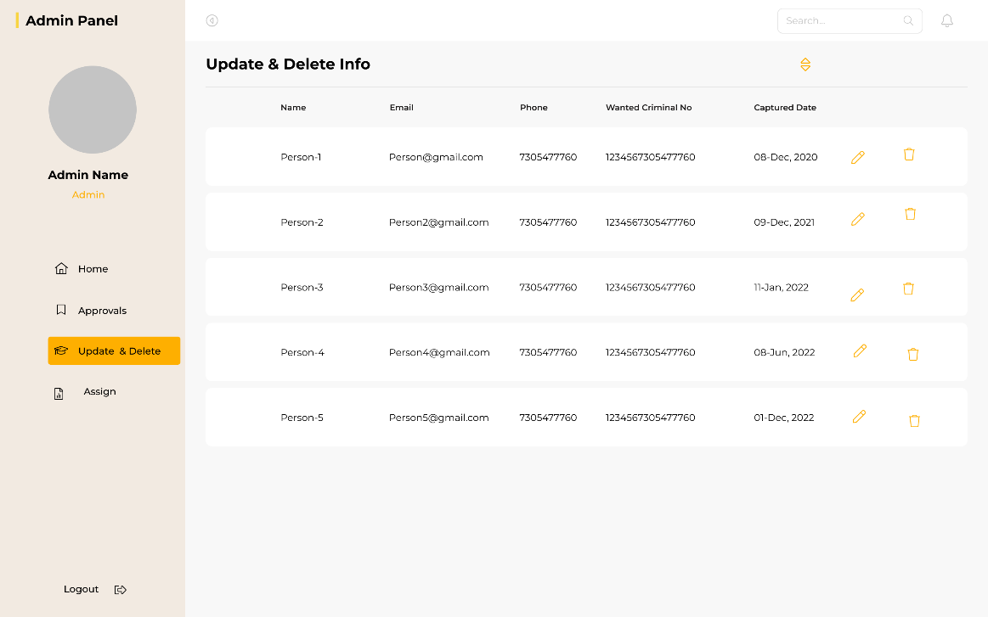

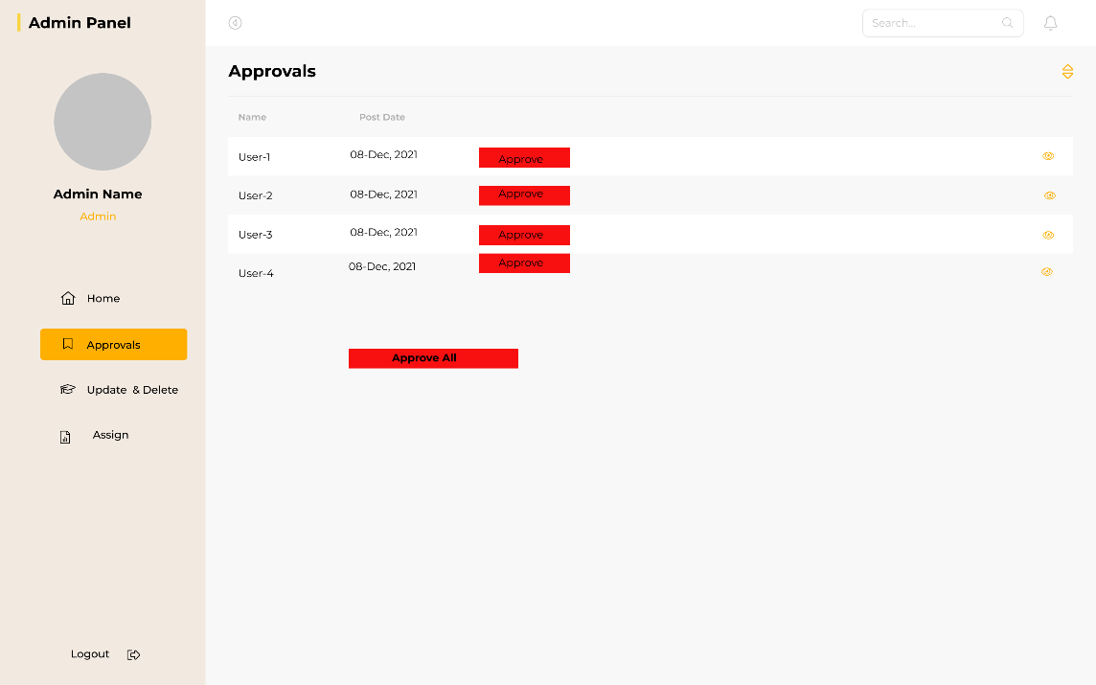

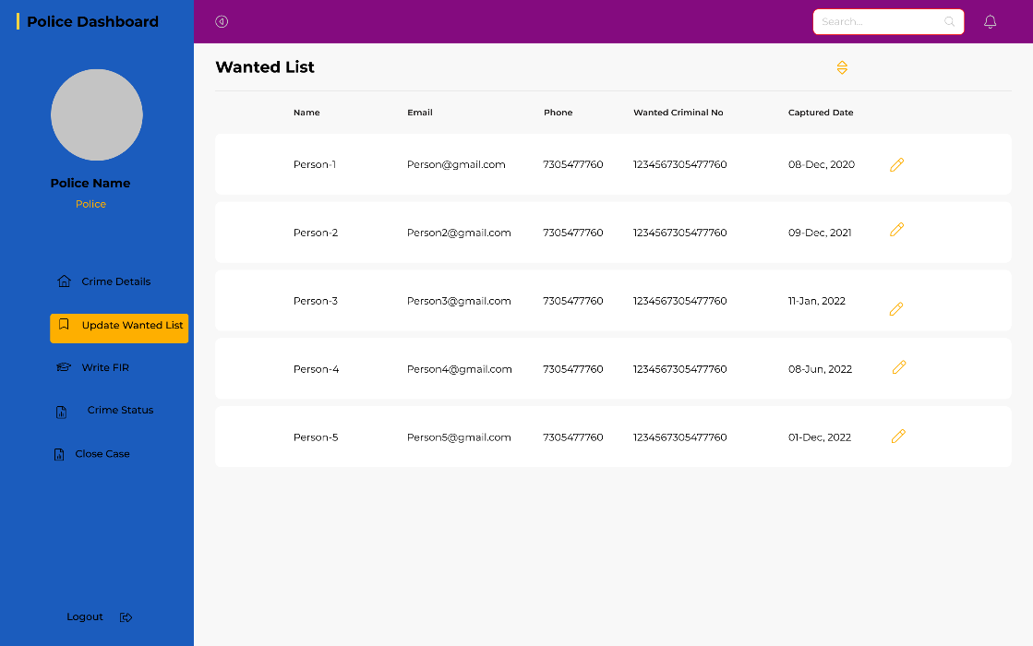

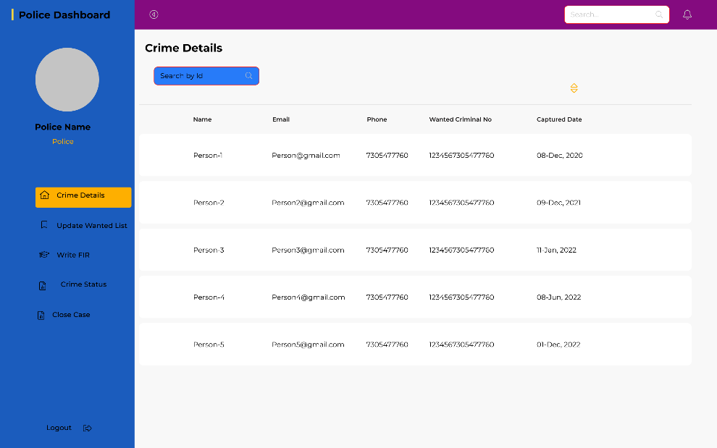

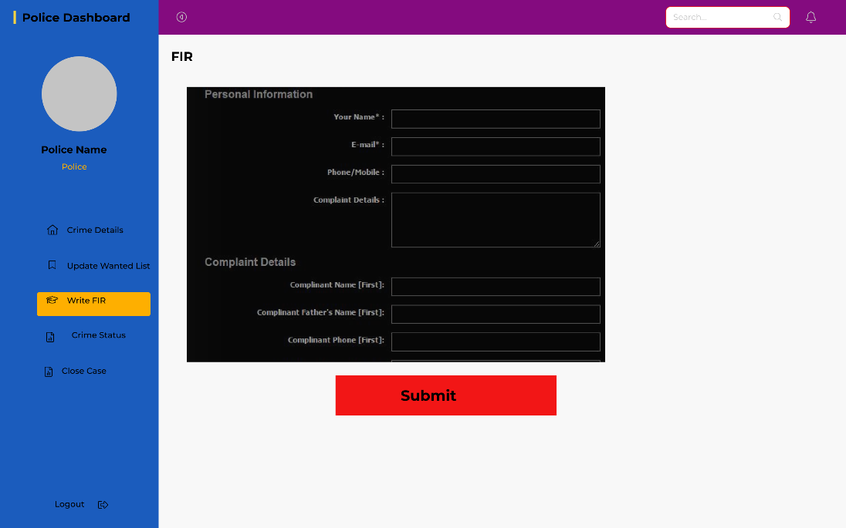

## Project Requirements

Let’s, assume our project is an organic project, where a= 2.4, b =1.05, c=2.5, d=0.38 according to the COCOMO model

The estimated size of the software product in Kilo Lines of Code is 100

Estimation of Development Effort, E= a × (KLOC)b

= 2.4 × (100)1.05

= 302.14209 PM

= 48,342.7344 Person-Hours

Estimation of Development Time, D= c × (E)d

= 2.5 × (302.14209)0.38

= 21.90 Months

Required number of people = PM/DM

= 302.14/21.90 = 14

Let’s assume average salary of each employee in our company is TK 50,000 and they work 8 hours each day

Therefore, Rate of per hour = 50,000 ÷ (14 × 8)

= TK 446.428 per hour

Cost = Effort × Rate = 48,342.7344 Person-Hours × TK 446.428 per hour

= 21581400.95 Taka

# FEATURES NOT TO BE TESTED

A list of topics that won't be specifically discussed is provided below. As a result of other testing initiatives, all testing in these areas will be indirect.

1) Keeping track of previous users' records

2) Historical Data: Historical data testing can be omitted because it is not necessary for the functioning.

3) We avoided the user view feedback functionality here in Features.

# TESTING APPROACH

## Testing Levels

The testing for the project will consist of Unit, System/Integration (combined) and Acceptance test levels. It is hoped that there will be at least one full time independent test person for system/integration testing. However, with the budget constraints and timeline established; most testing will be done by the test manager with the development teams’ participation.

The white-box testing tests the systems internal architecture. In order to verify that internal operations are carried out in accordance with specifications and that all internal modules are correctly implemented, white-box testing necessitates a tester to step through the code line by line.

UNIT Testing is one of the basic steps that is performed in the early stages. The testers will see if a particular cord unit is working or not. This helps to eliminate basic and simple bugs. The testing will be done by the developers and will be approved by the development team leader. Proof of unit testing (test case list, sample output, data printouts, defect information) must be provided by the programmer to the team leader before unit testing will be accepted and passed on to the test person.

SYSTEM/INTEGRATION Testing is mostly used to examine how various modules interact with one another when integrated into a larger system. The procedure is carried out following unit testing and will be repeated each time a new module is introduced to the system. The interface between the system's components is the main focus of system/integration testing. The test cases will be performed by our test manager and development team leader with assistance from the individual developers.

ACCEPTANCE Testing will be performed by the actual end users with the assistance of our test manager and development team leader. They will determine whether or whether our system satisfies all user needs.

## Test Tools

The only test tools to be used are the standard AS/400 provided utilities and commands.

The use of test tools is an important element of the software development process since it allows developers to confirm that the software is working properly and satisfies the required specifications.

There are numerous software applications available in the business that can be utilized to evaluate a software application. The following are some common examples of testing software that could be used in this context:

* Selenium is an open-source, automated testing tool for web applications that is used to test them across many browsers. Selenium is only capable of testing web apps.
* JMeter is used to performance testing tool for evaluating the performance of a software application under various load situations.
* User Zoom: This is a user experience testing tool that have been used to evaluate the software application's usability, accessibility, and overall user happiness. User Zoom is a UX tool meant to assist product developers and improve digital brand experiences.
* Postman: Postman is used as a manual testing tool in this project. Postman has been used to write functional tests, integration tests, regression tests, and more.
* Microsoft Project: This is a popular bug tracking and project management application in the software industry. It has features and capabilities such as the ability to generate and manage issues, track progress, and interface with other tools and platforms.

Overall, there are numerous software applications that may be utilized to industry-level test the Crime management and reporting system software application. The specific tools used may vary depending on the project's demands and objectives.

## Meetings

A software testing meeting is a gathering of individuals involved in the testing of a software program to discuss the testing's progress, any concerns that have been detected, and any necessary future steps. This could entail discussing the testing results, identifying any errors or vulnerabilities in the software, and deciding how to address these issues. The meeting's purpose is to confirm that the software works properly and meets all of the essential standards before it is made available to the public. Attendees at the software testing meeting may include, among others, the project manager, senior test engineer (test lead), junior test engineer, testing manager, and database analyst.

These individuals may provide testing process updates, describe any difficulties that have been detected, and provide feedback on how to fix these issues. The meeting may also include a review and discussion of test results, as well as any updates or upgrades to the software that are required.

Overall, a software testing meeting is a crucial aspect of the software development process since it allows those involved in testing to collaborate on assuring the project's success.

7. **TEST CASE/TEST ITEMS**

|  |  |  |  |  |  |
| --- | --- | --- | --- | --- | --- |
| Project Name: Crime Detection and Management system | | | Test Designed by: Romona Magdalene Sarkar | | |
| Test Case ID: CDM_1 | | | Test Designed date: 15/3/2023 | | |
| Test Priority (Low, Medium, High): Medium | | | Test Executed by: Romona Magdalene Sarkar | | |
| Module Name: Login | | | Test Execution date: 29/3/2023 | | |
| Test Title: verify login with valid username and password | | |  | | |
| Description: Test website login page | | |  | | |
| Precondition (If any): User must have valid username and password | | | | | |
| Test Steps | Test Data | Expected Results | | Actual Results | Status (Pass/Fail) |
| 1. Open the website 2. Enter username 3. Enter password 4. Click submit | Username: xyz@gmail.com  Password: 1234 | User should login into the application | | As expected, | Pass |
| Post Condition: User is validated with database and successfully login to account. The account session details are logged in the database. | | | | | |

|  |  |  |  |  |  |
| --- | --- | --- | --- | --- | --- |
| Project Name: Crime Detection and Management system | | | Test Designed by: Romona Magdalene Sarkar | | |
| Test Case ID: CDM_2 | | | Test Designed date: 15/3/2023 | | |
| Test Priority (Low, Medium, High): Medium | | | Test Executed by: Romona Magdalene Sarkar | | |
| Module Name: User Registration | | | Test Execution date: 3/4/2023 | | |
| Test Title: User can register/sign up with a new Gmail account | | |  | | |
| Description: Test registration page | | |  | | |
| Precondition (If any): User must have a Valid Gmail Account | | | | | |
| Test Steps | Test Data | Expected Results | | Actual Results | Status (Pass/Fail) |
| 1. Go to the website 2. Input Gmail Account, First name, Last name, NID, date of birth, phone number and password. 3. Register to the system 4. Click submit | Username:  xyz@gmail.com  Password: 1234  First name: Romona  Last name: Sarkar  Phone number: 01715087577  NID: 012 345 6789 | User can register/sign up their own account | | As expected, | Pass |
| Post Condition: Users data are validated and stored in. The account session details are logged in the database. | | | | | |

|  |  |  |  |  |  |
| --- | --- | --- | --- | --- | --- |
| Project Name: Crime Detection and Management system | | | Test Designed by: Romona Magdalene Sarkar | | |
| Test Case ID: CDM_3 | | | Test Designed date: 16/3/2023 | | |
| Test Priority (Low, Medium, High): High | | | Test Executed by: Romona Magdalene Sarkar | | |
| Module Name: User Post Complain | | | Test Execution date: 4/4/2023 | | |
| Test Title: Test complain have been posted | | |  | | |
| Description: Test complain if posted and approved by the admin | | |  | | |
| Precondition (If any): User must have valid username and password | | | | | |
| Test Steps | Test Data | Expected Results | | Actual Results | Status (Pass/Fail) |
| 1. Login to the website 2. Post complain 3. Click submit | Username: xyz@gmail.com  Password: 1234 | User should be able to post and wait for admin approval. | | As expected | Pass |
|  | | | | | |

|  |  |  |  |  |  |
| --- | --- | --- | --- | --- | --- |
| Project Name: Crime Detection and Management system | | | Test Designed by: Romona Magdalene Sarkar | | |
| Test Case ID: CDM_4 | | | Test Designed date: 16/3/2023 | | |
| Test Priority (Low, Medium, High): Medium | | | Test Executed by: Romona Magdalene Sarkar | | |
| Module Name: Report a file | | | Test Execution date: 5/4/2023 | | |
| Test Title: Test a report if submitted or not | | |  | | |
| Description: Test website report file page | | |  | | |
| Precondition (If any): User must have valid username and password | | | | | |
| Test Steps | Test Data | Expected Results | | Actual Results | Status (Pass/Fail) |
| 1. Login to the website 2. Input description and documents 3. Report a file 4. Click submit | Username: xyz@gmail.com  Password: 1234  Description: able to describe the situation  Documents : xyz.pdf/ xyz.jpg/xyz.png | User should be able to report a file | | As expected, | Pass |
| Post Condition: Users documents and reports are stored in the database. | | | | | |

|  |  |  |  |  |  |
| --- | --- | --- | --- | --- | --- |
| Project Name: Crime Detection and Management system | | | Test Designed by: Shahriar Hossain Rafi | | |
| Test Case ID: CDM_6 | | | Test Designed date: 17/4/2023 | | |
| Test Priority (Low, Medium, High): Medium | | | Test Executed by: MD. Shakibur Rahman | | |
| Module Name: User View status | | | Test Execution date: 6/4/2023 | | |
| Test Title: View Status for reported case or complain | | |  | | |
| Description: users can view the status for their reported case file and complain in the system | | |  | | |
| Precondition (If any): User must request for a complain | | | | | |
| Test Steps | Test Data | Expected Results | | Actual Results | Status (Pass/Fail) |
| 1. Go to the website 2. Login to the system 3. Click view status page | Username: shr@gmail.com  Password: 1234 | User can view their Case Status | | As expected, | Pass |
| Post Condition: User is validated with database and successfully login to account. The account session details are logged in the database. | | | | | |

|  |  |  |  |  |  |
| --- | --- | --- | --- | --- | --- |
| Project Name: Crime Detection and Management system | | | Test Designed by: Shahriar Hossain Rafi | | |
| Test Case ID: CDM_7 | | | Test Designed date: 17/3/2023 | | |
| Test Priority (Low, Medium, High): Medium | | | Test Executed by: MD.Shakibur Rahman | | |
| Module Name: User View status | | | Test Execution date: 7/4/2023 | | |
| Test Title: View Status for reported case or complain | | |  | | |
| Description: Users can view the status for their reported case file and complain in the system | | |  | | |
| Precondition (If any): User have to be logged in | | | | | |
| Test Steps | Test Data | Expected Results | | Actual Results | Status (Pass/Fail) |
| 1. Go to the website 2. Login to the system 3. Click view Safety post | Username: sr@gmail.com  Password: 1245 | User can view safety post | | As expected, | Pass |
| Post Condition: User is validated with database and successfully login to account. The account session details are logged in the database. | | | | | |

|  |  |  |  |  |  |
| --- | --- | --- | --- | --- | --- |
| Project Name: Crime Detection and Management system | | | Test Designed by: Shahriar Hossain Rafi | | |
| Test Case ID: CDM_8 | | | Test Designed date: 18/3/2023 | | |
| Test Priority (Low, Medium, High): Medium | | | Test Executed by: MD.Shakibur Rahman | | |
| Module Name: View news board | | | Test Execution date: 8/4/2023 | | |
| Test Title: View News in the system | | |  | | |
| Description: users can view news posted by admin in the system | | |  | | |
| Precondition (If any): User must request for a complain | | | | | |
| Test Steps | Test Data | Expected Results | | Actual Results | Status (Pass/Fail) |
| 1. Go to the website 2. Login to the system 3. Click view News Board page | Username: la@gmail.com  Password: 3456 | User can view the news board | | As expected, | Pass |
| Post Condition: User is validated with database and successfully login to account. The account session details are logged in the database. | | | | | |

|  |  |  |  |  |  |
| --- | --- | --- | --- | --- | --- |
| Project Name: Crime Detection and Management system | | | Test Designed by: Shahriar Hossain Rafi | | |
| Test Case ID: CDM_9 | | | Test Designed date: 18/3/2023 | | |
| Test Priority (Low, Medium, High): High | | | Test Executed by: MD.Shakibur Rahman | | |
| Module Name: Update & Delete info | | | Test Execution date: 9/4/2023 | | |
| Test Title: Update and delete any info from the system | | |  | | |
| Description: Admin can delete and update information from the system | | |  | | |
| Precondition (If any): Admin must take permission from user to update information. | | | | | |
| Test Steps | Test Data | Expected Results | | Actual Results | Status (Pass/Fail) |
| 1. Go to the website 2. Login to the system 3. Click Update and delete page 4. Update an information and delete an information | Username: admin@gmail.com  Password: admin | Update and delete info | | As expected, | Pass |
| Post Condition: admin successfully login to account. Information that will be updated and deleted will be validated in the system | | | | | |

|  |  |  |  |  |  |
| --- | --- | --- | --- | --- | --- |
| Project Name: Crime Detection and Management system | | | Test Designed by: Shahriar Hossain Rafi | | |
| Test Case ID: CDM_10 | | | Test Designed date: 19/3/2023 | | |
| Test Priority (Low, Medium, High): High | | | Test Executed by: MD. Shakibur Rahman | | |
| Module Name: Approve post | | | Test Execution date: 10/4/2023 | | |
| Test Title: Approve post from user | | |  | | |
| Description: Admin approve post from users into the system | | |  | | |
| Precondition (If any): Admin must login to the system | | | | | |
| Test Steps | Test Data | Expected Results | | Actual Results | Status (Pass/Fail) |
| 1. Go to the website 2. Login to the system 3. Go to the post approval page 4. Approve a post from user | Username: admin@gmail.com  Password: admin | Admin can approve post from user | | As expected, | Pass |
| Post Condition: Post will be validated in the database and will be shown in the system. | | | | | |

|  |  |  |  |  |  |
| --- | --- | --- | --- | --- | --- |
| Project Name: Crime Detection and Management System | | | Test Designed by:Md.Shakibur rahman | | |
| Test Case ID: CDM_11 | | | Test Designed date:19/3/2023 | | |
| Test Priority (Low, Medium, High):Hig | | | Test Executed by: Shahriar Hossain Rafi | | |
| Module Name: Investigation team | | | Test Execution date: 12/4/2023 | | |
| Test Title: Assign investigation team | | |  | | |
| Description: Admin can assign police officers for a particular case judging by their experince in the system. | | |  | | |
| Precondition (If any): Admin must assign police officers to particular case by their experience. | | | | | |
| Test Steps | Test Data | Expected Results | | Actual Results | Status (Pass/Fail) |
| 1. Go to the website 2. Login to the system 3. Click the assign investigation team page 4. Assign the investigation team | Username: shakibur521@gmail.com  Password: 564 | Admin can assign police officer to the investigation team | | As expected, | Pass |
| Post Condition: User is validated with database and successfully login to account. The account session details are logged in the database. | | | | | |

|  |  |  |  |  |  |
| --- | --- | --- | --- | --- | --- |
| Project Name:  **Crime Detection and Management System** | | | Test Designed by:Md.Shakibur rahman | | |
| Test Case ID: CDM_12 | | | Test Designed date:20/3/2023 | | |
| Test Priority (Low, Medium, High): Medium | | | Test Executed by: Shahriar Hossain Rafi | | |
| Module Name: **Search Crime details** | | | Test Execution date: 13/4/2023 | | |
| Test Title: search crime detail list | | |  | | |
| Description: police can search any crime details. | | |  | | |
| Precondition (If any): Crime details must be stored in the system with a unique id. | | | | | |
| Test Steps | Test Data | Expected Results | | Actual Results | Status (Pass/Fail) |
| 1. Go to the website 2. Login to the system 3. Click the crime detail page 4. Search for any crime detail. | Username: shakibur521@gmail.com  Password: 564 | Crime details can be searched. | | As expected, | Pass |
| Post Condition: User is validated with database and successfully login to account. The account session details are logged in the database. | | | | | |

|  |  |  |  |  |  |
| --- | --- | --- | --- | --- | --- |
| Project Name:  **Crime Detection and Management System** | | | Test Designed by:Md.Shakibur rahman | | |
| Test Case ID: CDM_13 | | | Test Designed date: 20/3/2023 | | |
| Test Priority (Low, Medium, High): High | | | Test Executed by: Shahriar Hossain Rafi | | |
| Module Name:  **Update wanted list** | | | Test Execution date: 14/4/2023 | | |
| Test Title:  **Update the criminal wanted list in the system** | | |  | | |
| Description: police can update and delate wanted list in the system . | | |  | | |
| Precondition (If any): police must be login the system. | | | | | |
| Test Steps | Test Data | Expected Results | | Actual Results | Status (Pass/Fail) |
| 1. Go to the website 2. Login to the system 3. Click the wanted listpage 4. Update and delete wanted list. | Username: shakibur521@gmail.com  Password: 564 | Update and delete wanted list. | | As expected, | Pass |
| Post Condition: User is validated with database and successfully login to account. The account session details are logged in the database. | | | | | |

|  |  |  |  |  |  |
| --- | --- | --- | --- | --- | --- |
| Project Name:  **Crime Detection and Management System** | | | Test Designed by:Md.Shakibur rahman | | |
| Test Case ID: CDM_14 | | | Test Designed date: 21/3/2023 | | |
| Test Priority (Low, Medium, High): High | | | Test Executed by: Shahriar Hossain Rafi | | |
| Module Name: Write FIR | | | Test Execution date: 15/4/2023 | | |
| Test Title:  Write FIR for a particular case | | |  | | |
| Description: police can write a FIR for a case in this system . | | |  | | |
| Precondition (If any): police must investigate properly to write the FIR. | | | | | |
| Test Steps | Test Data | Expected Results | | Actual Results | Status (Pass/Fail) |
| 1. Go to the website 2. Login to the system 3. Click the write FIR page 4. Write and FIR. | Username: shakibur521@gmail.com  Password: 564 | Written FIR can be shown in the system. | | As expected, | Pass |
| Post Condition: User is validated with database and successfully login to account. The account session details are logged in the database. | | | | | |

|  |  |  |  |  |  |
| --- | --- | --- | --- | --- | --- |
| Project Name:  **Crime Detection and Management System** | | | Test Designed by:Md.Shakibur rahman | | |
| Test Case ID: CDM_15 | | | Test Designed date: 21/3/2023 | | |
| Test Priority (Low, Medium, High): High | | | Test Executed by: Shahriar Hossain Rafi | | |
| Module Name: crime status | | | Test Execution date: 16/4/2023 | | |
| Test Title: crime status for a case can be posted. | | |  | | |
| * 1. Description: Police can update crime status from their investigation   . | | |  | | |
| Precondition (If any): Crime status should be updated within 7 days. | | | | | |
| Test Steps | Test Data | Expected Results | | Actual Results | Status (Pass/Fail) |
| 1. Go to the website 2. Login to the system 3. Click the crime status page 4. Update crime status. | Username: shakibur521@gmail.com  Password: 564 | Users can see the crime status | | As expected, | Pass |
| Post Condition: User is validated with database and successfully login to account. The account session details are logged in the database. | | | | | |

.

|  |  |  |  |  |  |
| --- | --- | --- | --- | --- | --- |
| Project Name: | | | Test Designed by:Md.Shakibur rahman | | |
| Test Case ID: CDM_16 | | | Test Designed date: 22/3/2023 | | |
| Test Priority (Low, Medium, High): High | | | Test Executed by: Shahriar Hossain Rafi | | |
| Module Name: **Close the case** | | | Test Execution date: 17/4/2023 | | |
| Test Title: close the case in the system. | | |  | | |
| * 1. Description: Police can close the case.   . | | |  | | |
| Precondition (If any): Police must give final investigation report about the case to close the case. | | | | | |
| Test Steps | Test Data | Expected Results | | Actual Results | Status (Pass/Fail) |
| 1. Go to the website 2. Login to the system 3. Click the case close page 4. Close down a case | Username: shakibur521@gmail.com  Password: 564 | case will be close. | | As expected, | Pass |
| Post Condition: User is validated with database and successfully login to account. The account session details are logged in the database. | | | | | |

# ITEM PASS/FAIL CRITERIA

We have conducted total number of 16 test cases. At first 80 % of the test cases were successfully passed. 20% of the test cases failed in the system. There were many codes related as well as query related issues in the system. When these issues were resolved all test cases successfully passed.

# TEST DELIVERABLES

* Acceptance test plan
* System/Integration test plan
* Unit test plans/turnover documentation
* Screen prototypes
* Report mock-ups
* Defect/Incident reports and summaries
* Test logs and turnover reports

# STAFFING AND TRAINING NEEDS

In any project, staffing and training are important. Project managers, test managers, and test engineers must receive this training instruction on the use of every project tool. The team leader or project manager will act in this position if test items are not currently trained or accessible.

• Skilled personnel and teams are crucial for successful project delivery.

• Testing should be done to ensure that personnel and workers are qualified for the project.

• Skill-based training sessions can be scheduled to develop and ensure various skills.

• The team includes a project manager, senior test engineer (test lead), junior test engineer, testing manager, database analyst, and other professionals.

• The project manager can take over or replace the junior engineer with someone who has the necessary abilities if a senior test engineer is unavailable for a period of time.

# RESPONSIBILITIES

|  |  |  |  |  |  |
| --- | --- | --- | --- | --- | --- |
|  | Team Manager | Project Manager | Development Team | Test Team | Client |
| Acceptance test Documentation & Execution |  |  |  |  |  |
| System/Integration test Documentation & Exec. |  |  |  |  |  |
| Unit test documentation & execution |  |  |  |  |  |
| System Design Reviews |  |  |  |  |  |
| Detail Design Reviews |  |  |  |  |  |
| Test procedures and rules |  |  |  |  |  |
| Screen & Report prototype reviews |  |  |  |  |  |
| Change control and regression testing |  |  |  |  |  |

# TESTING SCHEDULE

The project schedule includes time for the upcoming testing activities. The project plan timetable specifies the precise hours and dates for each task. The project manager, working with the development and test team leaders, will coordinate the employees needed for each task, the test team, the development team, management, and the customer. A project management application named GanttPro online tool has been used for scheduling.

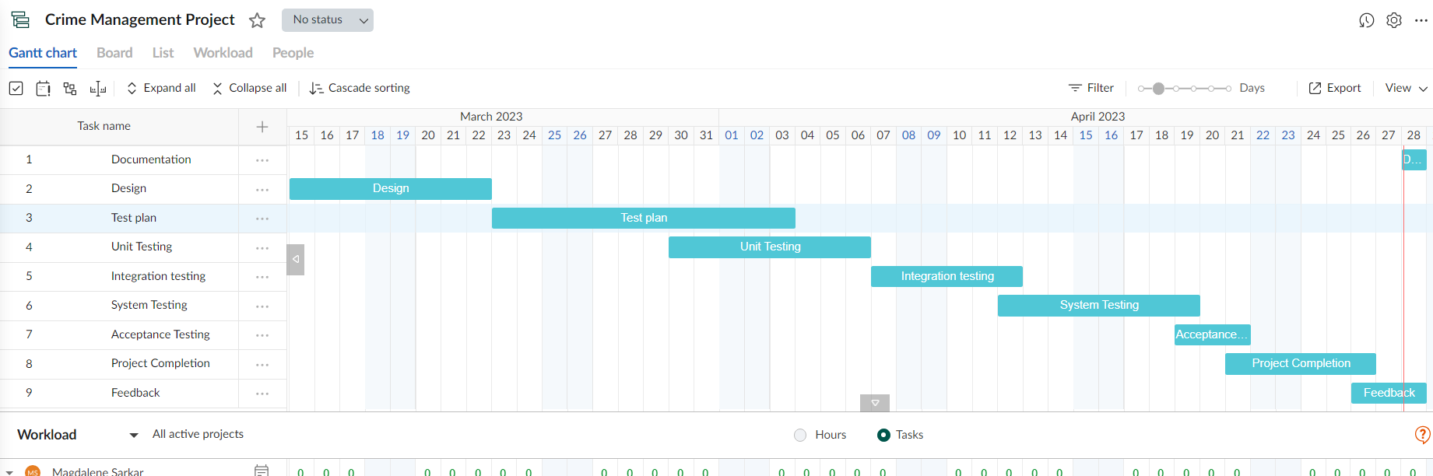

# PLANNING RISKS AND CONTINGENCIES

Several planning risks and unexpected things happen as a project is being prepared. Technical debt, which is brought on by poor code, can potentially negatively impact a project's success. This type of code may be difficult for other developers to read and understand, which may make it difficult for them to maintain or modify the code. Additionally, hastily written or inadequately tested code may have a large number of defects that damage the software's general functionality. Stakeholder communication that is effective is essential to a software development project's success. The project's progress and overall success may be hampered if stakeholders are not involved and do not give feedback and input on time. In order to mitigate these risks and ensure the success of a software development project the following steps can be taken:

o Identifying risks and triggers.

o Categorize and prioritize them.

o Monitor risks and act accordingly

# APROVALS

|  |  |
| --- | --- |
| **Project Sponsor -** Ismail Hossain Rishad | Approved |
| **Developer Management -** MD. Shahzad Hussain Rayied | Approved |
| **EDI Project Manager -** Shahriar Hossain Rafi | Approved |
| **RS Test Manager -** Romona Magdalene Sarkar | Approved |
| **RS Development Team Manager -** MD. Shahzad Hussain Rayied | Approved |
| **Reassigned Sales -** Lima Akter | Approved |
| **Order Entry EDI Team Manager -** Md. Shakibur Rahman | Approved |